MY TEA POT. YOUR TEA POT

BELLA DONNA - Wholistic Healthcare Facilitator, www.BeeHealthy.biz
Beekeeper, Herbalist, Aromatherapist, Apitherapist

TEAPOTTING

If you’re even driving down the road with me, don’t be surprised if I slam on the brakes at a sight of some wild elderberries in full bloom, or an old peach tree on the side of the road.

When I lived in the Midwest I harvested sage, dandelions, peppermint, peach leaves, rosemary, and other wild and planted herbs for my own tea blends. In the high desert of central Arizona, I collected chaparral, Mormon tea, blackberry leaves, brittle bush, globe mallow, and others medicinal delights. Now, living at the southern tip of the Appalachian Mountains in northern Georgia, I am collecting a plethora of more wild and cultivated plants than I ever imagined. “The hills are alive…” is what I think every time I’ve wandering around in my own yard or woods. There is hardly anywhere I can go here and not see something delicious.

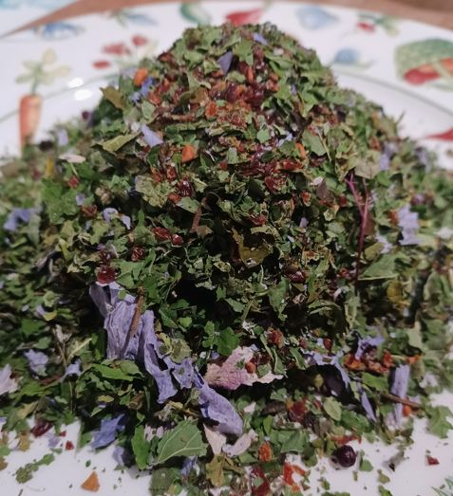
Throughout most of the year, daily between early spring to late fall, I am collecting something to dry. My poor dehydrator can sometimes run for weeks, three eight-hour cycles, round the clock. The spring months offer young, tender plantain leaves, early wild violets, young maple leaves, and a bounty of sassafras roots. If there is any local tree removing going on at my property or close by, I’m always hopeful to harvest pine needles from the ponderosa pine; this is the easiest pine to identify with three needles per socket.

My dried collection has gone into a number of different size and shaped vessels over the years. A half-gallon of blended herbs tends to last me at least a year. Whatever is captured in my collection at any time is “my tea pot.” With the layering of the different herbs from different seasons, and unique blending together of wild plants, herbs, tree leaves, roots and barks, constantly changing and evolving, there is much enjoyment to the subtle flavor variations of each honey sweetened and delicious cup of health and heaven.

Over the years I’ve encouraged others to have their own “tea pots” as a collection of unique, local, and personal favorite herbals. You can think of this similar to sour dough starter. You start with a base of herbs, from your own collection, from a friend, or from a bought package. Pour it into a jar, decorative vessel, or any type of container. I started with pint jars years ago, then graduated to quarts and half gallons. Now I use gallons or big old vintage cookie jars. You can make your own with something having sentimental value to you. Our tea drinking enjoyment starts way before the first sip.

Today, as you are reading this, I’d like to suggest, encourage, and challenge you to start your own “tea pot.”

HERE’S HOW:

- Begin with exploring what edible herbs are right out of your back door. There is a tradition health practice of ‘eating local’, not just to support local but because it is better overall for our health.
- Here is some information if you are interested in knowing more about this. https://5seasonsdiet.com/eating-with-the-seasons.
- And here is a free downloadable link to a great book Staying Healthy with the Seasons by Elson M. Hass. https://best.shoopbook.com/?q=1587611422

- Consciously and lovingly collect what you find, wash each piece of plant material off really well with running water. Dry well. I dry by wrapping in a towel loosely for a few hours, even sometimes overnight. The process of drying herbs for tea is simple and will become routine to you quickly.

- Lay plants in your dehydrator, following directions with temperature and time, and rotating racks halfway through the process.

- When completely dry, grind or crush into small piece and put into your container.

- Every day or every few days, or even once a week or once a month, you can collect more dried herbs to add to your “tea pot.”

- You can use the herbs as-is, 1 teaspoon per cup of not-quite-boiling water. Or you can cut 50/50 with black, green, white, or rooibos tea. The rooibos is a favorite of mine and many others who do well to avoid caffeine.

Common North American plants that make up a quality, healthy, and nutritious blend, and are found nearly everywhere on the planet, include any or all of the following.
  - Lavender, rosemary, or thyme leaves and blossoms are international herbal standards.
  - Parsley, cilantro, and different varieties of basils are fun to explore.
  - Blackberry or raspberry leaves are packed with nutrients; the younger the better.
  - Echinacea leaves, flowerheads and roots, all work well in most herbal blends.
  - Oranges, lemons, limes, and grapefruits, whole dried fruits including seeds can be used.
  - Citrus leaves, without pesticides, also add a refreshing flavor to blends.
  - Mint varieties can include spearmint, peppermint, orange mint, lemon mint, and citrus and many other interesting flavors.
  - Peach tree leaves offer a mild, fruity flavor to blends.
  - Rose blossoms and rose hips infuse a nice calmness to any cup of tea.
  - Lemon balm and fennel add a fresh feeling to the taste buds.

Explore and experiment; notice how some teas taste better during certain season. Citrus blends are refreshing in the summer months. Heavier flavors or root blends are more beneficial to us during the colder months.

Have fun, enjoy the self-exploration between you and nature, be healthy. Stay healthy, and be sure to share your “teapotting” experience with friends and family.

References to Mountain Rose products:
Seeds- https://mountainroseherbs.com/search.php?search_query=seeds
Dried Herbs- https://mountainroseherbs.com/search.php?search_query=dried+herbs
Books- https://mountainroseherbs.com/search.php?search_query=books+drying+herbs
Jars- https://mountainroseherbs.com/search.php?search_query=decorative+jars

