USING STEVIA TO HELP WITH SUGAR BALANCES
Here is an article on Stevia. It is great for balancing blood sugar levels. I've seen much success with it in friends and family members
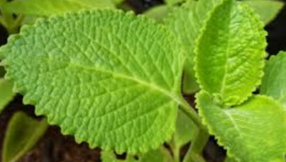
https://www.medicalnewstoday.com/articles/323376.php

A 2016 study reported that dried stevia leaf powder significantly lowered blood sugar levels in people with diabetes, both while fasting and after eating. The participants in the study also saw a reduction in their triglyceride and cholesterol levels.

And NO, I’m not referring to a bleached out, commercially made white powder.

My best recommendation is this, which has a proven track record of making a huge difference in sugar balancing, even with extreme diabetes, “use a little every day.”

Each morning make a cup of stevia tea, using a scant teaspoon of the dried herb with 1 cup of almost boiling water. This gives you one cup of stevia water to use throughout the day.

First thing in the morning you can add a teaspoon or tablespoon to your tea.

You can add a few teaspoons to morning grains or in stir fried vegetables.

You can add a couple teaspoons to salad dressing any time during the day.

You can pretty much add it to anything you eat or drink all day long.
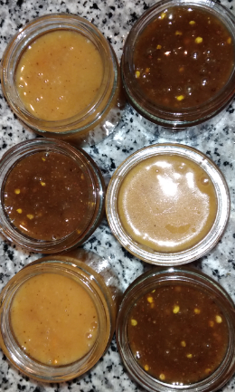
You can blend 3 T. with 1 t. of cinnamon, drizzle over fruit and bake or broil. Pears and apples work well.

If you are currently on my AutoShip program for the Super Honey and would like a packet of fresh, dried, organic Stevia added to your monthly order, the cost is only an additional $5.00. It can be added and charged to your monthly bill.
Contact me at: BellaBHBH@aol.com

