Wellness Evaluation
Bella Donna- Oriental Bodywork Therapist, Health/Wellness and Life Coach
www.BeeHealthy.biz 805 620 8266

ZYTO BALANCE - WELLNESS REPORT
CLIENT NAME: SAMPLE
DATE OF SCAN: February 23, 2018

BIOMARKERS SCANNED: 172
IN RANGE: 99 OUT OF RANGE: 73
PERSONAL RANGE:

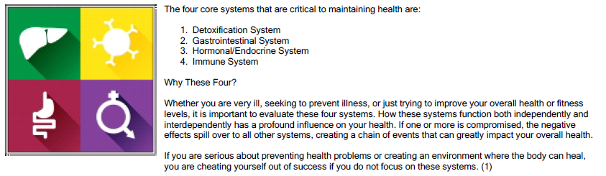

FOUR CORE SYSTEMS: Immune System mostly impacted. Rest is in order- jump off the treadmill for a bit.
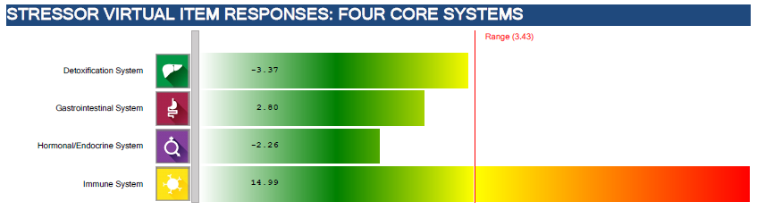

LIFESTYLE AREAS: Hydration causing some kind of strain on your overall health. Too much, lack of?
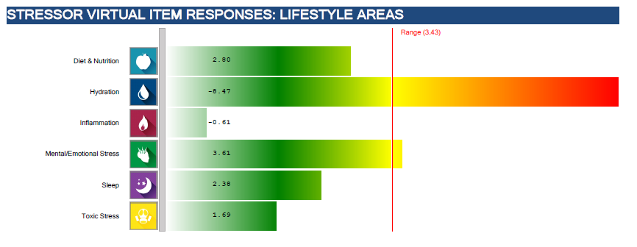
DETOXIFICATION SYSTEM 1. Be more conscious with diet and nutrition
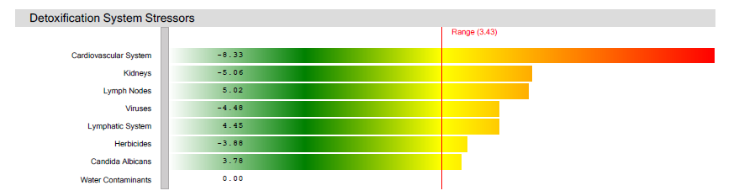

GASTROINTESTINAL SYSTEM
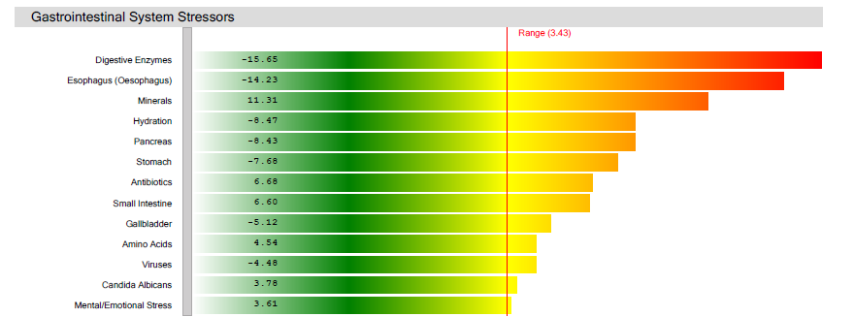

HORMONAL/ENDROCRINE SYSTEM
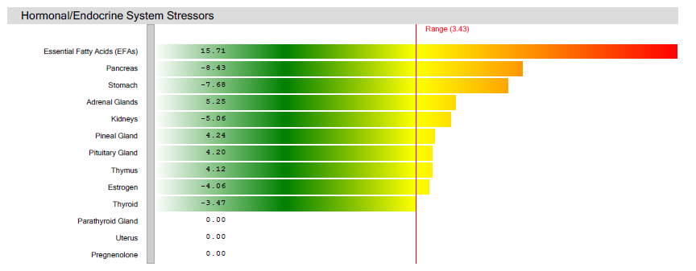

IMMUNE SYSTEM – A taxed spleen is from overdoing. Antibiotics are naturally products with bacteria in the body.
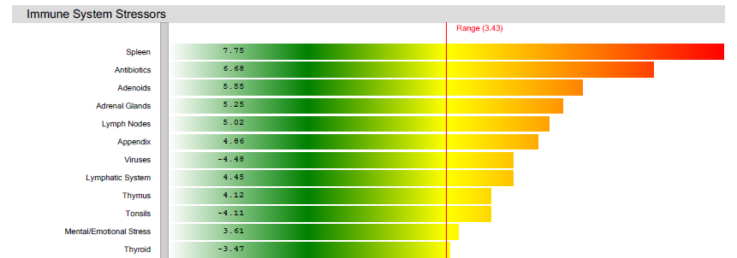

DIET AND NUTRITION- Too many fatty acids and digestive enzymes? Too many minerals. Too much work for the body to process, especially the liver.
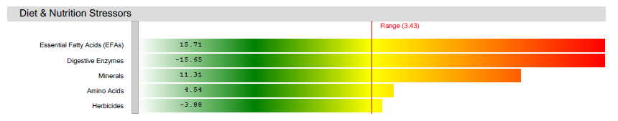

HYDRATION
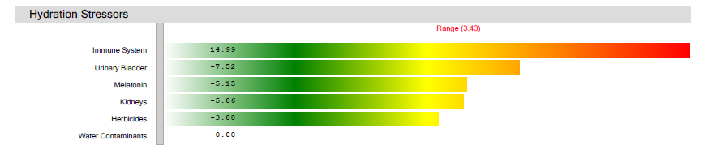

INFLAMMATION
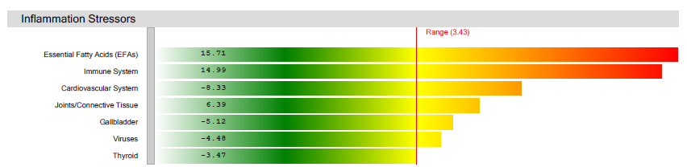

MENTAL AND EMOTIONAL STRESS – Not being happy with what ‘just is.’
Exercise- Spend one day at home, or even a full half day. Don’t say anything out loud. Listen to what you say to yourself? Are your thought happy with what is, or does something always need to be changed? Listen at how you talk with yourself, what you say, what you ask, how you reply. Be conscious of your breathing and your deep breathing.
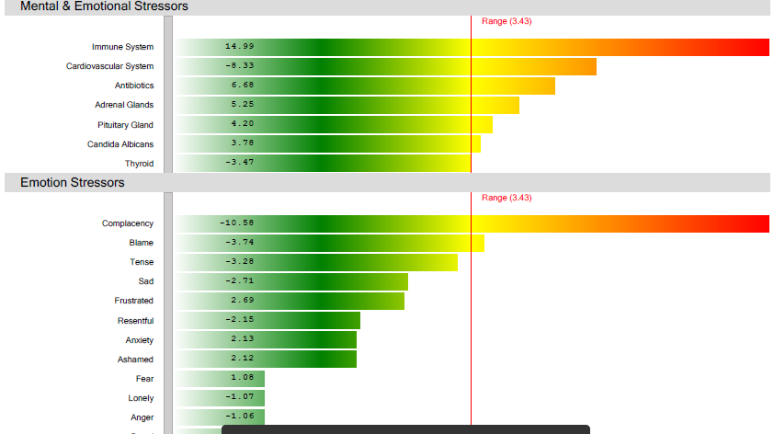

SLEEP
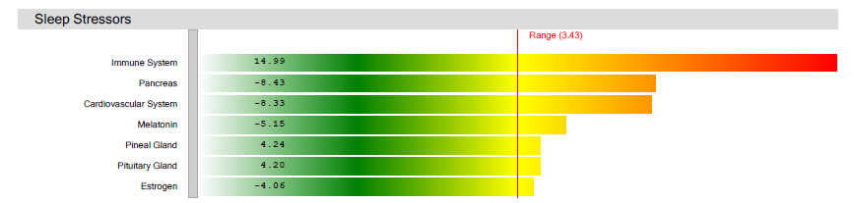

TOXIC STRESS- Stress impacts the immune system, which lowers the immune, setting the body up for viral infections.
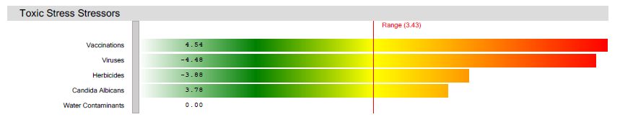

ADDITIONAL SERVICE RECOMMENDATIONS:
None listed

VECTORS- Impact of a strained kidney on other parts of the body, per Chinese Traditional Medicine
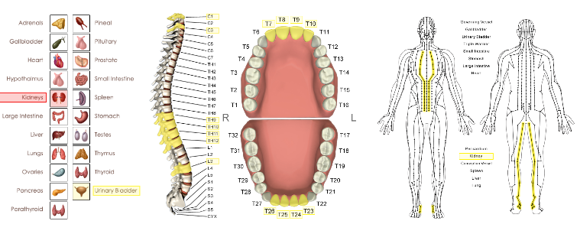

PRODUCT/PROTOCOL RECOMMENDATIONS:

This is the most recommended supplement, bringing more than half of the points back into balance. Just be careful taking this, or anything, with other protocol recommendations. It can just create more stress and strain and work on the body. And more is not always good; in fact, less seems to have the best positive impact with supplements and especially essential oils.

NSP - Kidney Activator Chinese 3 Capsules 3 times per day
Kidney Activator Chinese (100 caps)
$25.00
Kidney Activator Chinese formula was designed to promote kidney function and help clear retained water from the body, which
may positively affect joints.
Benefits:
Promotes kidney function.
May help clear retained water.
Supports the urinary tract.
May support joint health.
Supports the lymphatic system.
How It Works:
The Chinese name for this formula, qu shi, can be translated to mean “clear the dampness.” Morus root bark is thought to help
eliminate excess moisture. Hoelen was used historically by the Chinese to “drain dampness.” Alisma is said to help promote
the flow of moisture and is used in Traditional Chinese Medicine to support the bladder and urinary tract. According to Chinese
concepts, astragalus may help to clear retained water from the body.
Ingredients:
Hoelen sclerotium, siler root, chaenomeles fruit, morus root bark, astragalus root, alisma rhizome, plantago seed, peony root
without bark, atractylodes rhizome, magnolia bark, polyporus sclerotium, citrus peel, cinnamon twig, ginger rhizome,
typhonium rhizome and licorice root.
Recommended Use:
Take 3 capsules with a meal three times daily. NOTE: Pregnant or lactating women should consult their health care provider
prior to taking this supplement.

ParaCleanse- Black Walnut Tincture- 2 droppers in the a.m. and 2 dropper in p.m. $15.00

Vitamic C- 1 t. three times each day Liquid $13.00

Green tea with Pau de Arco and Stevia, and licorice root and milk thistle honey- tea and honey $20.00

You Tube- https://www.youtube.com/watch?v=JFpkRoqHujk

It’s all a balancing act.

Here are some others idea to helping control blood pressure naturally:

* Each day, try doing something that brings you joy. I don’t care if it’s a favorite craft, clipping coupons, playing cards or doing a crossword puzzle. When you make time to do this, you reduce stress.
* Breathe deep long slow breathes. Several times a day do this and imagine all tension and negativity being released with every exhale.
* Be mindful of your mental chatter. Correct it when you find it is being too self critical or critical of others.
* Replace negative thoughts with positive ones.
Examples:
- I face problems with calm assurance
- My body desires only healthy foods
- I am healthy in all aspects of my being and body
- Every cell in my body vibrates with energy and health.
- Most important to help high blood pressure---- I joyously release the past. I am at peace.

RELATIONSHIP BETWEEN HEART AND LIVER

Both organs are the blood related – filtering, processing, cleaning.

Some things that help with the balance of the ‘blood’ organs are:

Relaxation
Relaxation can be in different forms and this is a very natural to calm the flow of blood hence minimizing the workload effect on the liver, kidney, heart and the blood vessels.

Proper Food and Nutrition
Foods, herbs, and spices serve various functions in the body but they mostly function for the liver, kidney, heart, and blood vessels. They include;

Foods- that improve the liver, kidney and cardiovascular health are any substance consumed which provides nutritional value to the body as well as improve health.

They include the following:
1. Food- fresh and organic always best
√ Fresh fruits
√ Vegetables including lots of fresh greens and sprouts
√ Sea fish and Herring (Fish and oil containing omega-3 and omega-6 fatty acids) Not sure where we can get good, clean fish of any kind these days
√ Chicken and beef liver
√ Low-fat and non-fat dairy product

2. Herbs- that help to improve the liver, kidney, cardiovascular health are numerous but discussing a few of them is only appropriate. They are the leafy and green part of plants extracted to improve health and include:
√ Licorice
√ Milk thistle
√ Basil (Or essential oil- 2 drops each day, morning and evening)
√ Green tea – Not coffee, not black tea, not red tea

3. Spices- are those substances gotten from the part of the plant that is not the leaf but rather parts like the stem, root, bulb, bark or seeds. They help to bring health to the liver, kidney and cardiovascular system.
They include;
√ Cinnamon
√ Turmeric
√ Garlic
√ Nutmeg

