OCTOBER NEWSLETTER 2018
BELLA DONNA, PO BOX 43, LOOKOUT MOUNTAIN, TN 35370
BellaBHBH@aol.com www.BeeHealthy.biz

Greeting Y’all !

Q: What’s up here???
A: A LOT!!!

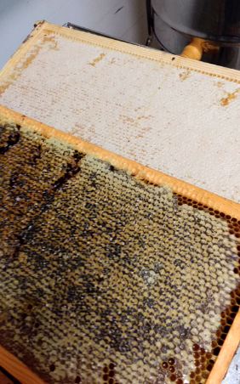
I bought some unbelievable rich and creamy honey from a guy here in southern Tennessee recently. It seems chocolaty. I’m hoping to get some more from him to have it pollen tested. He has no idea what the bees are hauling but he says that every spring he gets this thick, dark chocolate-consistency honey from one of his locations. I’ll keep you posted.

Last week I spend hours hand-extracting from frames pulled out of hives this spring that ranged from an almost clear honey, to milky creamy, to deep dark. When I hand-harvest I make sure to preserve the most amount of pollen. This gives honey the thick richness not normally found in commercial, store-bought or even small farm honeys that quantity extract. When honey is spun in an extractor (the most commonness way), a lot of the pollen is held in the frames so you’re not getting the full benefit of it.

Every step along the way I continue to make our Super Honey with THE BEST processing and quality ingredients available in the world. You might notice your honey changing month to month in color, consistency and flavor; rest assured, you can get no better blend.

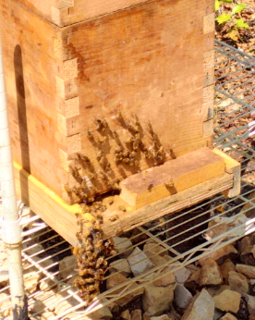
God-willing, your next shipment will be coming from me in New Salem, Georgia. For now, you are getting a 50% bonus!

The bees have gotten all settled in before I have and are doing very well. This picture is the one breeder hive that I hauled from Arizona in the trunk of my car in April. I have done a split of it to two hives, and each hive continues to grow as I add more boxes to the top. I’ve acquired four other wild hives since being here with hopes of a great spring in 2019 when I can continue to split hives and also raise my own queens. Queens are a huge and expensive part of beekeeping.

And I love it all.

Thanks for traveling this route with me and supporting my work and your health.

Bee Well, and thank you for your ongoing prayers, concerns and patience during my transition. God bless us all!!!

Bella

