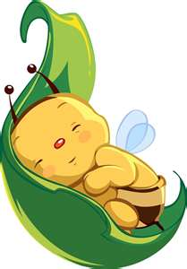
BEE HEALTHY
NEWSLETTER DECEMBER 2018
www.BeeHealthy.biz
BellaBHBH@aol.com
POB 43, Lookout Mountain, TN 37350

Greetings and Happy Holidays to you all. Or should that be ya’ll? As we’re preparing for the holidays and even another New Year, I pray we not get over stressed, over challenged, over tired, or over spent- physically or financially.

As you can see from the above picture of the sleeping bee, they have been put to rest for the winter. This year I was up to six hives but going into winter with only three now. God be with them!!! I say that every day. During my last hive exam, chasing away of wasps that were totally destructive this year, I had to remove a couple frames with some wax and honey. So that was exciting to see, feel and taste (the honey, not the wasps). I’m saving it in case I have to fed it back to them this winter and if not for a lucky batch of Super Honey.

Since I noticed I’m gathering more honey from far-away places, I’m going to start tracking and sharing better with you in 2019. I am also getting more focused on upping-my-game with my Super Honey in any way that I can. (Any suggestions on that, I’m all ears.) My Super Honey is always high priority in the array, or sometimes disarray, of my life.

Also, I am prepping for some trips next year. In May I’ll be in Albuquerque, NM, speaking to a crowd of beekeepers on Apitherapy- Healing from the Hive. From there I’ll be attending an Herbal Conference in Durango, CO, and hopefully doing some harvesting.

In June I have a quick trip to Arizona for some of the same. I’m speaking at the www.SWHerbFest.com on Herbal Infusions on Saturday, the 1st. Then on Sunday, the 2nd, I’ll be doing a demo at The Healing Garden in Prescott, entitled From the Ground Up- Planting beginning with making your own compost. These events are listed on their website at: www.SWHerbFest.com. It will be fun to see some of you there. I also will schedule a day for some hike/harvesting around the Sedona area, and some scan times. I am planning and hoping to be there Thursday thru Tuesday.

God bless you all throughout this holiday season. Winter is our time to kick back a bit, hibernate- physically, emotionally and mentally, get extra sleep, eat some warmer foods and teas- root foods and spice teas, and contemplate.

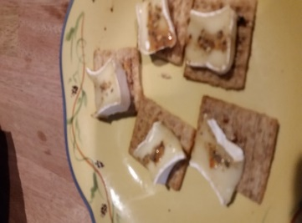
If you have any last-minute gifts to send, want to introduce anyone to some healthy products, or want to gift yourself anything special, keep in mind my products that I carry year-round- Scent-a-Bella, Blended Specialty Honey (Ginger-elderberry and Lavender right available), Propolis, and my BeeHealthy Tea- a blend of all organic black, green, red and green rooibos. I can special gift wrap and ship anything, anywhere, any time.

HERE IS A DELICIOUS, LITTLE, SWEET, AND EASY TO MAKE SNACK
Top any cracker or rice cake with a small slice of brie and drizzle with honey. I used my elderberry-ginger today. You can warm in a pan on the stove, or inside the over. And you can experiment with different types of soft cheese. I also sprinkle with bee pollen.

