MUSHROOM GARDENING FOR MAN, BEAST AND THE PLANET- PART 1, JUNE 2018

There are multiple reasons for mushroom gardening. The basic three are:
- It makes the best compost for the vegetation around it by symbiotically nurturing the soil, plant life, insects and microorganisms. And it’s also great for permaculture and sustainability of the planet.
https://mycosymbiotics.blog/about/
- Provides a natural and healthy human food containing antiviral, antibacterial and antifungal properties.
https://www.organicfacts.net/health-benefits/vegetable/health-benefits-of-mushroom.html
http://www.earthsfirstfoods.com/mushrooms/mushrooms-and-health/
- Offers nutritional value to foraging bees, and probably other insect which help their natural defenses against viruses that are becoming too common to honeybees.
http://www.naturetimes.com/honeybees-feeding-mushroom-juice-4653

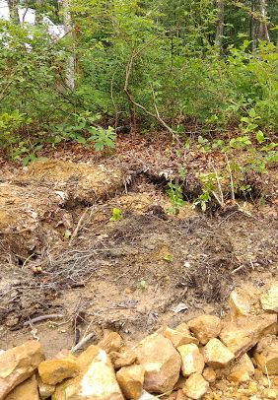
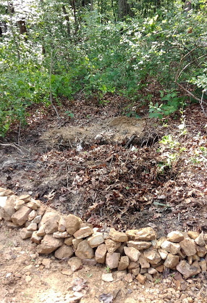
Addressing all three of these issues, I’ve recently started a demonstration/experimental mushroom garden in a small and shallow pit where a huge tree root had recently been removed. This left a nice, fertile area, approximately 6 foot by 6 foot, with plenty of daily shade yet a few hours of sunlight. Along with all the good, organic components already planted, I added additional leafs, yard mulch, small twigs, wood chips, and a randomly found banana peel . I bordered the front with rocks to prevent erosion and also to give more area to build the garden up.

Next, I will be adding in layers more local, dried leaves, organic sawdust, and straw, and fresh wood chips, along with purchases mushroom spores. I’ll be recording the progress.
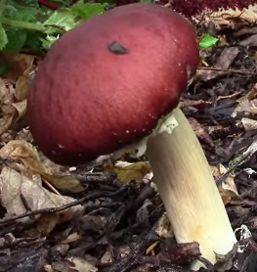
I choose Wine Cap mushrooms since I am not a fan of eating mushrooms and I heard that this variety has a nicely flavored nutty, almost wine taste to it. (I am hoping for something close to amaretto, which, to me, has an almondy flavor with cherry undertones.)

I purchased my spores from 2Angels Mushroom Farm in Chattanooga as they are very knowledgeable of the research on honey bee health and mushroom juice. https://www.2angelsmushrooms.com/farm-raised

