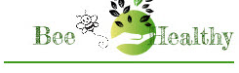
BEE HEALTHY JULY 2019
HEALTH NOTES FROM BELLA DONNA
www.BeeHealthy.biz BeeingBella@gmail.com
SUMMER LENTIL-BASIL SALAD

This recipe is easy, delicious and healthy.

Cook and rinse 1 cup of any type lentils just until they are soft. Then rinse in cold water and allow to drain well.

I’ve found a great product that I am
adding to about everything that I
cook, stir fry, boil or bake. It’s called
BEYOND BROTH with a website by
the same name. Their products are
pure and healthy, and easy to blend
into busy schedules and being on
the run.

In a serving bowl, mix the following:
½ cup good quality olive oil
4 T. balsamic vinegar
(I happen to have a fig infused one right now)
1 T. honey
1 T. or more, dried or fresh basil, or both
½ cucumber, cut in small chucks, some skin on
¼ yellow, orange or red pepper, chopped small
Some pickled sunchokes, artichokes or cheese
Salt and fresh ground pepper
Add lentils and mix lightly.
Refrigerate an hour. ENJOY

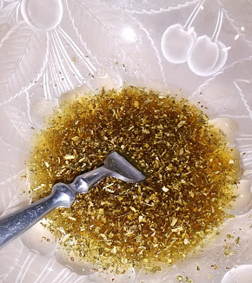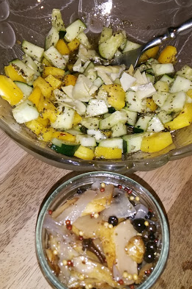
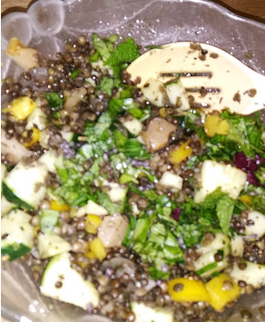
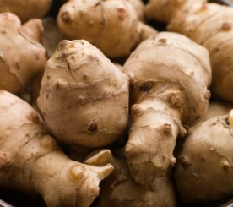
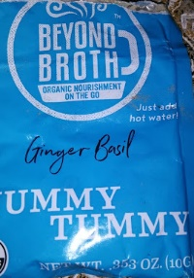
Enjoy the enclosed basil packet.
I thought it might encourage
the attached recipe.

SUNCHOKES- Jerusalem Artichokes

I have been growing these for over ten years as an ingredient in our Super Honey. I know there are many things you can do with it. I’ve only added to soups and stews, like a potato, to thicken the broth a bit. I just found some pickled sunchokes at a local farmer’s market and they are outta-this-world.

They provide numerous vitamics and minerals, thus the addition to the Super Honey. They are also noted as being a good prebiotic, and loaded with potassium and iron. And who doesn’t need all of that on a daily basis?

PAYMENT DUE UPON RECEIPT BELLA DONNA
$30.00 POB 43
LOOKOUT MOUNTAIN, TN 37350
THANK YOU EVERYONE FOR YOUR PROMPT PAYMENTS - MUCH APPRECIATED!!
Payment accepted: cash, check, PayPal, credit card, or direct deposit

