FERMENTED SUMMER BERRIES
This is a delicious and healthy snack. It cools in the hot summer months and is easily made with fresh berries. I’ve used strawberries, raspberries, blackberries, and blueberries. Strawberries will ferment within 24 hours, and other berries within 24-36 hours. This process builds up pre and probiotics in the berries and juice and is exceptional for gut health and the immune system.

The fermentation process is a way to help preserve the fruit. It can easily last a few weeks in the frig. Before storing in the frig, the fermentation increases pre and probiotics in the blend, offering a great aid to gut health.
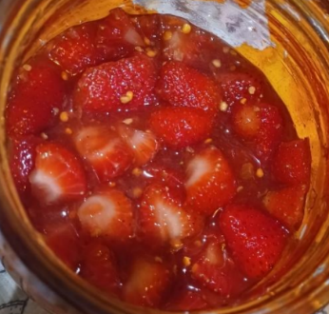
- Start with a sterilized canning jar.
- Fill with berries with 2-inch head space.
- Pack with fresh, washed berries.
- For each cup of berries, add the following:
1 T. honey
1 T. real maple syrup or sorghum
1 T. kombucha
Optional adds:
½ t. fresh bee pollen
½ t. l. glutamine (my tummy loves this stuff)
A fresh chunk of honeycomb with or without bee bread
- Cap. Then shake the jar daily for one to three days. Release pressure if it builds up.
- Eat or keep in the frig.
Pre and probiotics are best for the gut in small quantities, not as a meal replacement.

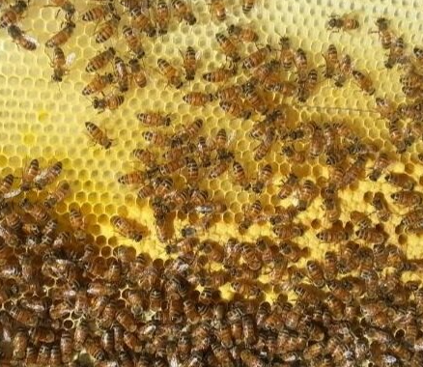

Copyright @Bella Donna, May 2023, Fermented Berries

