FRUIT, VEGGIE, CRACKER DIP

Blend the following in a food processor until smooth. Then refrigerate at least 8 hours to allow the flavors to meld.
8 oz. package of cream cheese, or 6 oz. of cream cheese and 2 oz. of soft brie
2 T. freshly chopped parsley or lemon balm
¼ cup chopped green onions
3 cloves chopped garlic
3 T. flavored vinegar- my preference is raspberry
¼ cup honey
4 T. nutritional yeast
½ t. mustard
¼ cup fresh blueberries

NUTRITIONAL YEAST
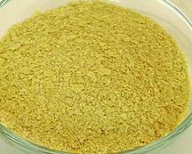
I love this stuff. It’s packed full of vitamins and minerals, and supplies the Vitamin Bs that I need daily, and in a health, natural form. It also helps provide energy, helps support the immune system, is good for our nails and hair, and can improve glucose sensitivity.

I think it adds a nutty flavor to foods and I add it to eggs, green drinks, meat dishes (after they are cooked), and just about anything that goes onto my plates.

