NATURALLY NOURISHING THE GUT FOR OPTIMUM HEALTH
Bella Donna, Apitherapist and Health Care Facilitator
Bellabhbh@aol.com; www.BeeHealthy.biz

Our gut health shows high implications to long-term, as well as short-term, all-round health. Keeping the gut healthy is of utmost importance to each one of us. Heal the gut, heal the body.

The gut and brain are connected via millions of nerves and are noted as controlling inflammation throughout the body. If the gut microbes affect the whole body, would changing and improving your gut bacteria improve your health, including your brain health?

Using Apitherapy (the use of honeybee products for health and healing), to address nourishing the gut in a natural and healthy way is simple and beneficial. Here are some specific gut imbalances and issues, with remedies of specific apitherapy applications.

INDICATIONS OF GUT IMBALANCE | REMEDIES | APITHERAPY APPLICATION
Upset stomach and traveling pains, caused by intestinal spasms | Fiber in diet | Mint-infused honey with fermented pollen
Candida/inflammatory from sugars | Honey as sweetener rather than sugars | Super Honey*, small quantity
Weight changes, up or down | Fasting between meals | Super Honey*, small quantity
Chronic Fatigue | No caffeine; Proper sleep | Super Honey*
Autoimmune issues | Fermented foods | Fermented honey and pollen
Food intolerances | Fermented foods | Fermented honey and pollen

For clients and myself, I use fermented, blended, and infused honeys. The varieties are endless to the different combinations that can be used to address gut issues, as well as many other health concerns. A good quality, pure, unprocessed honey, including the honeycomb, along with fresh pollen, are the magical ingredients. Here are some different blends revealing their sparkling deliciousness within each combination.
Here you can see, in a close-up, the actual hexagon pattern of the majestic honeycomb, as well as the start, shown with the bubbling up, to the fermentation process.

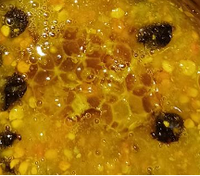
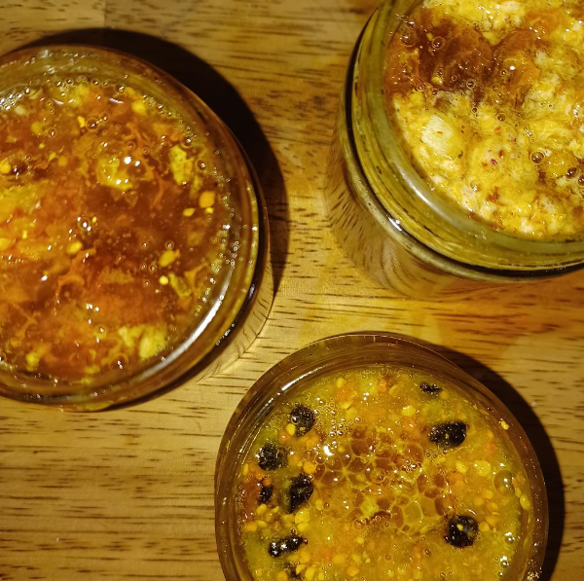
Ginger

Cranberry-Mulberry, Ginger, and Elderberry

Barberry and Ginger

To start the fermentation process, we need a live enzyme, contained in the natural, unprocessed pollen, and a specific degree of moisture. Any moist type additions, like cranberries, barberries, or fresh ginger, all contribute to the growing of probiotics in the naturally nutritious honey, although not necessary to start the fermentation process.

Leaving a loose cap or paper towel over the jar allows for air to ‘feed’ the live bacteria. If you’ve ever made anything like kimchi, yogurt, mead, or kombucha, it is the same process.

Making fermented honey with developing pre- and probiotics is both an art and a science. The art part is determining and developing ‘types’ of blends you want. The science part is getting the formula correct so you get a good, live fermentation process going without mold or other adverse results. Including honeycomb helps increase the enzyme content so its inclusion would be an example of both a science and art form of apitherapy.

Fermented honey, although very few on the planet have heard of it, has been used therapeutically for eons from Egyptians to ancient Indian cultures. Babylonian tablets have been found with recipes for honey medicine, and Russian beekeepers to this day record using “honey from the bottom of the hive” with “impurities of pollen, propolis and even bee parts. (www.Westonprice.org)

The Journal of the National Cancer Institute, in a 1948 article reported that bee pollen fed to rats halted the growth of cancerous tumors with some even becoming tumor-free after ingesting just small amounts of pollen added to their fed. This suggests the concentrated power of pollen in healing and curing cancer cells. This is one of many types of potential healings with pollen.

More recent studies show evidence of cancer cell death due to bee pollen’s peptides. Peptides are amino acids that can inhibit tumor cell proliferation. In addition, the treatment of autoimmune system disorders shows improvement due to pollen’s bioactivities such as antimicrobial, anti-inflammatory and antioxidant activities.

Which brings us back to where I started- heal the gut, heal the body.

Fermented honey blends, with information sheets, now available at: www.BeeHealthy.biz.

* Super Honey- A specialty blend of over ten different, pure, quality honeys including Manuka - for multi pollen content, with five additional fresh pollen varieties, and six other superfoods. This blend is a high-quality protein food with nearly all the minerals, vitamins, and nutrients that a human body needs to survive. Available at: https: //www.beehealthy.biz/apothecary

