LOVELY GREEN CHARCUTERIE BOARDS
For Holidays, Family Gatherings, or Special Events

What is a Charcuterie Board?

"There is nothing new under the sun" (Ecclesiastes 1:9) is a scripture/quote that comes to me often. Back in the early days of my life, small, quaint gatherings many times included "cheese boards." Cheddar and Swiss cheese, a dark and light offering, with saltines, and maybe one other choice cracker would grace a cutting board.

These days, with gathering more focused on larger groups, the traditional cheese board has evolved. Cheese Plate 2.0, I call it.

With charcuterie becoming so popular, I wanted to put a healthy or "green" spin on them. I've come up with ideas for food marrying that are both lovely and healthy.

Traditionally, charcuterie boards are covered primarily with meats and cheeses. In general, goat and feta cheese are lower in calories than most other cheeses. Mozzarella is also a low-calorie and low-sodium choice. Mozzarella also contains probiotic bacteria- Lactobacillus casei and Lactobacillus fermentum. Cheddar is a low-calorie, semi-hard, and yellow cheese, although also available in white.
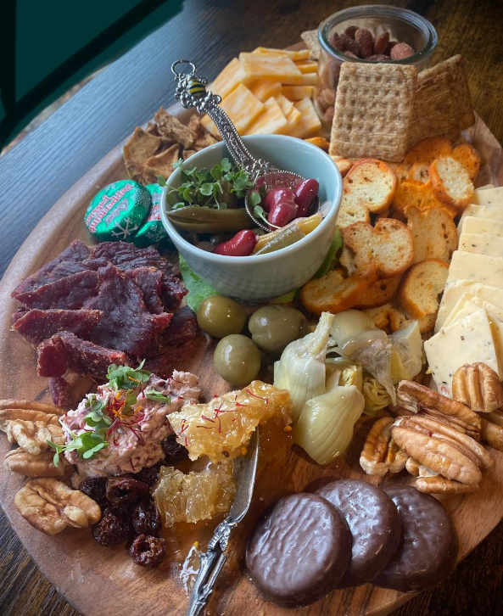
Additional possibilities of ingredients:
Greens
Sprouts
Chucked canned pears mixed with fresh chopped mints
Artichoke hearts
Fresh herbs- mints, thyme, parsley, cilantro
Bed of fresh greens or different types of kales
Figs and dates (Can be stuffed with soft cheeses.)
Lettuce for wraps
Celery and cucumber sticks
Broccoli
Rosemary sprigs for garnish
Tomato, basil, cheese curd kabobs
Green and red peppers
Greek yogurt
Beef Jerky pieces
Dippers:
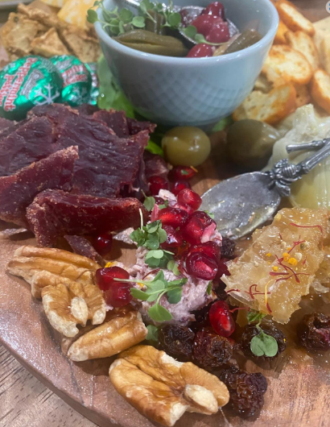
Unleavened breads or crackers
Toasted bagel pieces
Use small decorative bowls for:
Olives
Green grapes
Pickles
Guacamole
Honey spiced nuts
Green hummus (recipe below)
GREEN HUMMUS RECIPE
Blend well in a good, strong blender for 60 seconds.
¼ cup chopped chives or green onions
¼ cup lemon juice
1-2 cloves of fresh peeled garlic
¼ cup olive oil
1 15 oz can of chickpeas, or 2 cups freshly made garbanzo beans
¼ cup tahini or 5 T. sesame seeds and 5 T. olive oil
1 cup total of any greens- parsley, cilantro, arugula, spinach, sweet potato greens, basil
Salt and pepper

