FRUIT SMOOTHIE FOR CALMNESS
Blend all together:
1 cup frozen strawberries or other fruit mixes
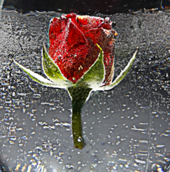
1 T. of honey or honeycomb
1 T. rosewater
1 cup yogurt
½ cup almond milk
1 t. vanilla extract or small bean piece
